Project Database Design

## **Views:-**

1. Simple View
   1. A view should have only single table select statement
2. Complex View
   1. A view should have more than one table select statement it means it suppose to be Join query

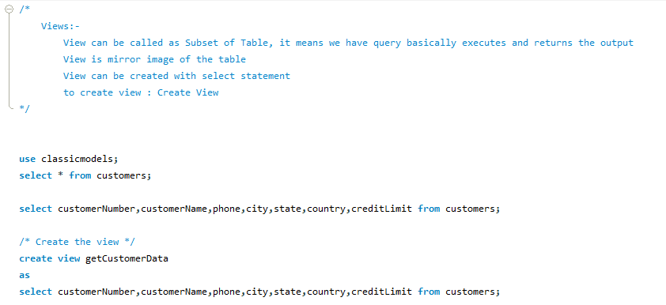

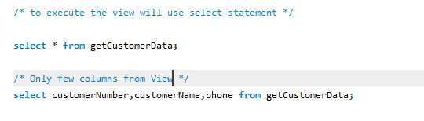

The record is not inserting here:



A view can be updated under certain conditions which are given below −

* The SELECT clause may not contain the keyword DISTINCT.
* The SELECT clause may not contain summary functions.
* The SELECT clause may not contain set functions.
* The SELECT clause may not contain set operators.
* The SELECT clause may not contain an ORDER BY clause.
* The FROM clause may not contain multiple tables.
* The WHERE clause may not contain subqueries.
* The query may not contain GROUP BY or HAVING.
* Calculated columns may not be updated.
* All NOT NULL columns from the base table must be included in the view in order for the INSERT query to function.

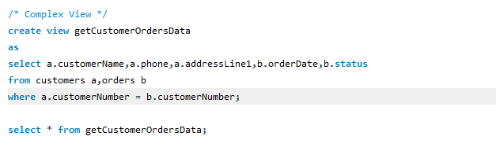



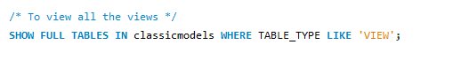

Table Rename:

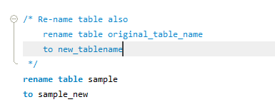

Table Alter :

